**113-51-10040 Tributary 1 ADDITION**

**Water body name: Survey date:** 8/4/2023

**Quad:** Sitka C-4 **Species & Lifestage:**

**Upper Reach Latitude:** 57.530490 **Longitude:** 135.1760024 **Survey crew:** DK, FC

**Lower Reach Latitude:** 57.527928 **Longitude: -**135.180776

**Findings:**We surveyed this uncataloged stream using a backpack electrofisher, baited minnow traps, and GPS and captured juvenile coho salmon and Dolly Varden (Table 1; Figures 1–3). Coho salmon were visually identified in this stream by Habitat Biologists due to an electrofisher malfunction; however, a photo of juvenile coho salmon caught at waypoint 444 (tributary 4) is included. Upstream of waypoint 524, the stream went subsurface for several hundred feet, then reforms where we captured only resident fish. Fish habitat continues upstream where continuous surface flow is reestablished.

**Recommendations:** Add this uncataloged stream to the anadromous waters catalog for rearing coho salmon to waypoint 524 (Figure 4).

**Nomination:** Pending

Table 1.–113-51-10040 tributary 1 survey data.



Table 1.–Continued.



|  |  |
| --- | --- |
| A picture containing tree, outdoor, water, river  Description automatically generated  Figure 1.–Channel at waypoint 443, facing upstream. | Figure 2.–Channel at waypoint 443, facing downstream. |

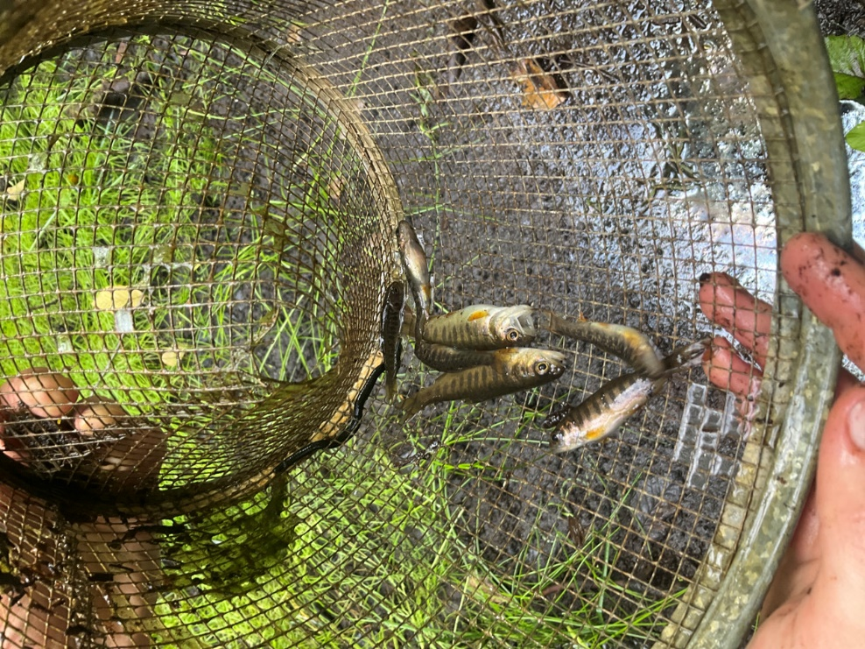

Figure 3.–Juvenile coho salmon caught in upstream tributary at waypoint 444.

Figure 4.– 113-51-10040 tributary 1 addition map.